Game Development Design Brief
Game Name | Game Icon |   Date |   Version |  | Notes By:
  Team Members |  |   Game Concept  Description of your concept or idea
  Problem  What is the problem you are solving |  |   MVP  The simplest version of your concept, identify which features are required for the minimal digital solution to the issue

Platforms


Existing Games

 |  |   Target Group  The audience you aim to target |  | 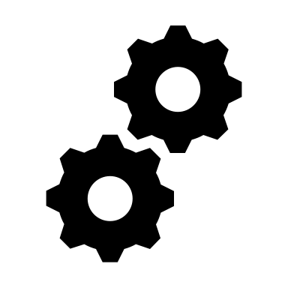  Characteristics  Identifying features of the Game
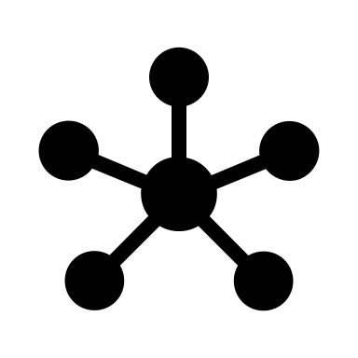  Core Features  Core features of your Game and their prioritization. Decide the order for the features to be developed, with the MVP features placed first |  |   Success Factors and Risks  Factors that will help you succeed. Identify and note potential risks, being sure to identify strategies to minimise these risks

Main Components
What are the main elements, objects and components of your Game

Vision
What would you like to accomplish within a certain timeframe

Design Plan Algorithms
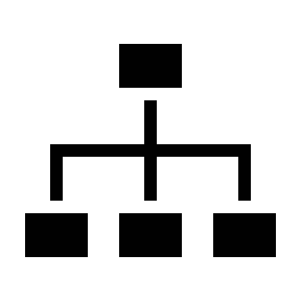  Algorithms - pseudocode  For each feature/component, represent the required attributes and related algorithms using pseudocode, with a brief description and code design (pseudocode) | Algorithms - Flowchart (draw.io)  For the main feature/component, represent the required attributes and related algorithms using a flowchart


UI/UX Design (draw.io)
Wireframe the Game user interface and experience.

Project Plan
  Timeline  The order features are to be developed and mark as completed.  The time allocated for a feature should include testing time as well as coding time.  Allocate time for user testing of the digital solution at key times during its development, and when the development is complete | Modifications  Document modifications made, give a brief reason for the change, addition or deletion of a feature or any modification.

